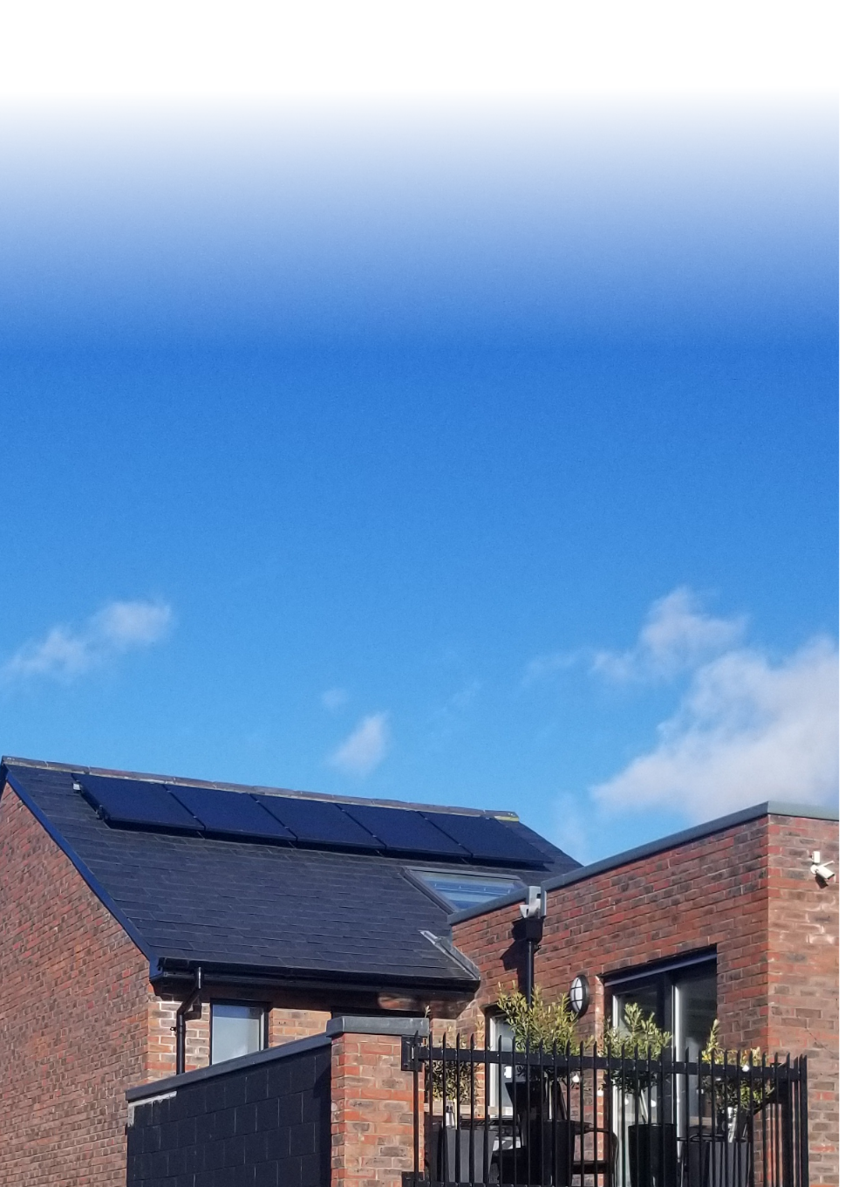
Proposal for
Supply and Install Of
Solar PV Energy System

Proposal For [Customer Name]
Address
Date

Complete _____ kW Solar Energy System
Panels

Inverter

Other Hardware

Installation and Commissioning

Documents and Certification

 | Price before tax | €
 | Tax | €
 | Price including tax | €
 | Incentives | €
 | Net Cost | €

Energy Generation Estimate

Your solar PV system is estimated to generate _____ kWh in the first year.

At a unit price of ______, your expected year 1 return on investment is _______.

Each solar panel generates as much electricity of its lifetime as about 5,000 kg of coal

Why Choose Us?

Quality

Installations are done by our team of expert installers. This lets us guarantee the highest standard of workmanship at every step of the process.

Value

We carefully select components to offer the sweet spot where quality and value meet.

Integrity

We believe it’s important to be honest about what solar panels can and cannot achieve. We strive to provide realistic and conservative projections about your electricity generation and savings.

Support

[company name here] stand over our work. Solar PV is a reliable technology that can work for years without issue. But if you ever do need backup, we’ll be there for you.

What Our Customers Say

“
[Testimonial 1 – Approx 3 Lines]
”
- [Name]

“
[Testimonial 2 – Approx 3 Lines]
”
- [Name]

“
[Testimonial 3 – Approx 3 Lines]
”
- [Name]

Questions
Please contact us with any questions and we will be happy to help you:
email: [your email here]
phone: [your phone here]

Terms and Conditions
This proposal is provisional, pending site survey.

Next Steps
When you’re ready to go solar, just follow these simple steps:

- [Step 1, e.g. “phone us on XXX”]
- [Step 2 e.g. “sign the contract and send us a copy”]
- [Step 3 e.g. “forward deposit to bank account XXX”]

